|  |  |
| --- | --- |
| **DATE** | **22 October 2022** |
| **TEAM ID** | **PNT2022TMID34173** |
| **PROJECT NAME** | **A Novel Method for Handwritten Digit Recognition System** |
| **MAXIMUM MARKS** | **8marks** |

**Product Backlog, Sprint Schedule, and Estimation (4 Marks)**

|  |  |  |  |  |  |  |
| --- | --- | --- | --- | --- | --- | --- |
| **Sprint** | Functional Requirement **(Epic)** | User Story Number | User Story/Task | Story  points | priority | Team members |
| **Sprint -1** | Download the  database | USN-1 | As a user I can register for the application by entering my email, password and confirming my password. | 2 | High | Rabisha.R |
|  |  |  |  |  |  |  |
| **Sprint -1** | Register | USN-2 | As a user I can register for the application by entering my email, password and confirming my password. | 2 | High | Rabisha.T |
| **Sprint -2** |  | USN-3 | As a user I will receive confirmation email once I |  | Low | Thanusiya.M |
| Login |  | have registered for the | 1 |  |  |
|  |  | application. |  |  |  |
|  |  |  |  |  |  |
|  |  |  |  |  |  |
|  |  |  |  |  |  |
| **Sprint -1** | Upload the image | USN-4 | As a user I must upload the image to identify the problem and works on it. | 1 | Medium | Thanisha.T |

Use the below template to create product backlog and sprint schedule

**Project Tracker, Velocity & Burndown Chart: (4 Marks)**

|  |  |  |  |  |  |  |
| --- | --- | --- | --- | --- | --- | --- |
| **Sprint** | **Total Story Points** | **Duration** | **Sprint Start Date** | **Sprint End Date (Planned)** | **Story Points Completed (as**  **on Planned End Date)** | **Sprint Release Date (Actual)** |
| Sprint-1 | 20 | 6 Days | 24 Oct 2022 | 29 Oct 2022 | 20 | 29 oct 2022 |
| Sprint-2 | 20 | 6 Days | 31 Oct 2022 | 05 Nov 2022 | 30 | 30 oct 2022 |
| Sprint-3 | 20 | 6 Days | 07 Nov 2022 | 12 Nov 2022 | 49 | 6 nov 2022 |
| Sprint-4 | 20 | 6 Days | 14 Nov 2022 | 19 Nov 2022 | 50 | 7 nov 2022 |

**Velocity:**

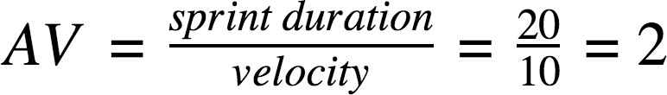

**Burndown Chart:**

